4th Grade: It’s Time for Recorders!

Dear Parent/Guardian:

Soon, your child will start playing the recorder in his/her 4th Grade Music class as part of the Pre-Band curriculum. The students and I will be covering the information in this letter to be sure each child understands the expectations regarding recorders. This is not a toy, but a real musical instrument. The students are very excited for the unit to begin!

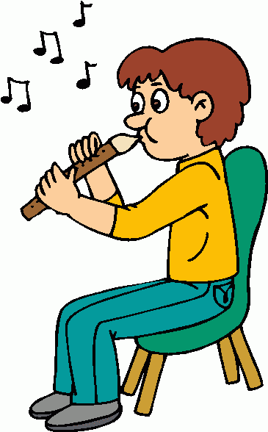
If you decide to purchase a recorder for your child, I ask that you purchase a Soprano 1 or 2 piece recorder. Some common brands are Tudor, “Candy Apples” by Tudor, Yamaha, and Angel brand recorders with average prices $4.00-$8.00. The following retailers are possible options for purchasing a recorder for your student:
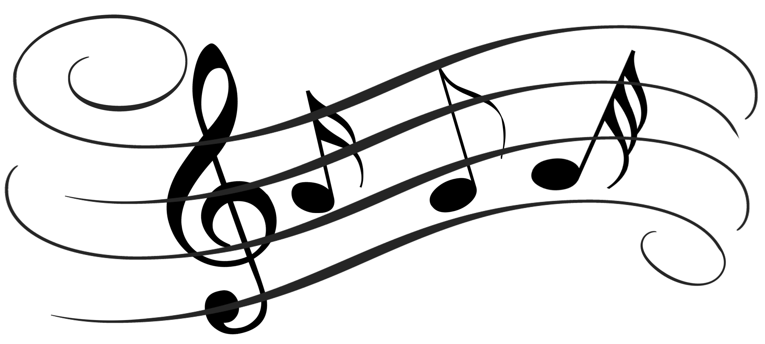
RentMyInstrument.com (877) 569-0240
McCourt’s Music (248) 546-4300

We have a limited number of school-owned recorders which you may rent from the school for no cost. The recorder would need to be returned to the school at the end of the unit. You may also bring an already purchased recorder from home.

We will be using the books Recorder Express and Making Music in the classroom this year. The music will be provided for the students during music class. If a student would like to practice at home in addition to music class, I can provide music for their at home use to return to the music classroom at the end of the recorder unit. You may also purchase the Recorder Express book online. The study of an instrument reinforces all of the musical concepts the students have learned in their years of general music classes. The recorder is an important part of the fourth grade music curriculum. Students are encouraged to take their instruments home to practice and share with you what they are learning. The following is the “recorder code of conduct.” It is strictly enforced.

- The recorders are to be played in two places ONLY: the music classroom and at home. If students play them anywhere else, (in the car, the halls, etc.) they lose the privilege of taking them home for a while. Not being able to take your recorder home makes it difficult to practice.

- Students are reminded to be sensitive to their families and practice at a convenient time and an agreed upon place in your home. Please discuss where and when this will be for your family. Practice at home is necessary for skill development. However, even 10 minutes several times per week will help your child’s skills grow!

- Students are expected to have their instrument in class for their lessons on their normal music day. It is part of their grade. (To replace school-owned lost recorders, students are charged $6.00.)

Your child has music class on the following day: Mrs. Barlow- Tuesdays & Thursdays Mr. Damer- Tuesdays & Fridays

We will start playing recorders on Tuesday, September 29th, 2015. If you have any questions, please do not hesitate to contact me: crossa@gaschool.com. Thank you for your interest and cooperation in this new endeavor for your student!

Sincerely,
Andrea Cross

